**QA Test Report**

Project: Swag Labs

Test: Kristian

Environment:

* Browser: Chromium
* OS: Windows 10
* Test Type: Functional Testing
* Automation tool: Playwright + Cucumber

**Test Summary:**

|  |  |  |  |
| --- | --- | --- | --- |
| **Feature** | **Scenario** | **Status** | **Remarks** |
| Filter | Filter the product from Z to A | Passed | Products sorted correctly in descending alphabetical order. |
| Login Functionality | User Login to Swag Labs | Passed | User was successfully redirected to the inventory page after login. |
| Logout Functionality | User Logout to Swag Labs | Passed | User successfully logged out and returned to login screen. |

**Detailed Test Results:**

**1. Feature: Filter**

* **Scenario:** Filter the product from Z to A
* **Steps:**
  1. Login to Swag Labs.
  2. Click the filter dropdown.
  3. Select "Name (Z to A)" option.
* **Expected Result:** Products should appear sorted from Z to A (descending order).
* **Actual Result:** Products correctly sorted Z to A.
* **Status:** Passed

**2. Feature: Login Functionality**

* **Scenario:** User Login to Swag Labs
* **Steps:**
  1. Navigate to Swag Labs URL.
  2. Enter valid username and password.
  3. Click the login button.
* **Expected Result:** User is redirected to the inventory page.
* **Actual Result:** User landed on inventory page.
* **Status:** Passed

### 3. Feature: ****Logout Functionality****

* **Scenario:** User Logout to Swag Labs
* **Steps:**
  1. Login to Swag Labs.
  2. Click the burger menu.
  3. Click the Logout option.
* **Expected Result:** User should return to the login page.
* **Actual Result:** User successfully logged out and redirected to login page.
* **Status:** Passed

**Overall Test Status:**

All scenarios passed. No bugs encountered.

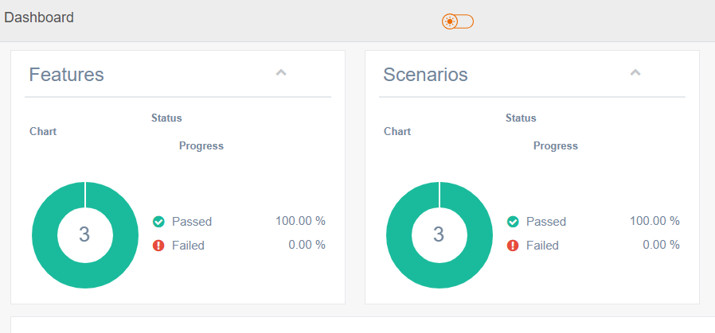

**References to complete the task:**

* Playwright: <https://playwright.dev/docs/api/class-locator>
* Spread Syntax: <https://developer.mozilla.org/en-US/docs/Web/JavaScript/Reference/Operators/Spread_syntax>
* Locale Compare: <https://developer.mozilla.org/en-US/docs/Web/JavaScript/Reference/Global_Objects/String/localeCompare>
* Sort: <https://developer.mozilla.org/en-US/docs/Web/JavaScript/Reference/Global_Objects/Array/sort>
* Gherkin Syntax Reference: <https://cucumber.io/docs/gherkin/reference/>
* Cucumber installation: <https://cucumber.io/docs/installation/javascript/>
* Playwright installation: https://playwright.dev/docs/intro